**Prog 109 – Module 10: Website Assessments**

Each validator has a pass / fail rating next to it and one or more screen shots below to show the full results. Each validator area has specific recommendations based on that validators results on how to improve or fix errors noted. In addition, there is a general Recommendations section before all the validator results, which covers general usability and accessibility recommendations.

**Web Site:** https://www.nasa.gov/

**Usability and Accessibility Recommendations:**

1. The keyboard usability and Accessibility is basically unusable. From when the page loads, the first tab gets you to the search box but the second doesn’t highlight anything. However it actually does go to the search magnifying glass icon because if you hit enter, you end up replacing your NASA site with googles search page. The third gets you to the main NASA logo on the upper left, which does nothing for you. The next goes way over to the far right past the search to what ultimately turns out to be some sort of social media icon (see item #2 below). Subsequent tabs take you through the secondary menu then into no mans land. Nothing is highlighted, nothing happens if you hit enter. Do this two more times with nothing and suddenly you are at the NASA TV main menu item. Subsequent tabs don’t show anything nor will enter get you anything until the 21st tab total, finally gets you to the first article text. It seems like the tabs are trying to go through the top menu items but they are not shown, nor are they active to the enter key. As a result, you don’t have access to almost all of the top menu. The tab also seems to hit the image links but may or may not be active to the enter key. Finally, once you do hit enter and go into a new page on the site, if you go back by hitting the back button (via mouse) the tab order starts all over again at the top of the page.

Recommendation: The tab order could be fixed, the locations highlighted or in some other way outlined (like the sub menu and lone main menu item) to show your current tab location, and the response of items to the enter key easily fixed. It could also save the last tab location of the page in local storage so that when you come back to the page from a subpage, it starts you at the place you left off.

1. The page is primarily filled with linked images with minimal text, except for the upper left article which seems to be the most recent newsworthy item. However, to the far upper right you have a “Nasa events” list with multiple items. Just below it is another image/link which is then followed by a tweets by NASA box that has a number of text links but is also itself a link, followed by another image link. I would have expected that if there was to be a NASA events box, that it would be followed by similar lists of things on the righthand side not another image link. This is compounded by the tweets box after that other image link and the image link after that. Further, why in the world would I care about what NASA re-tweeted at this stage of the site?

Recommendation: Remove the tweets box. If there needs to be more items on the page, expand the NASA events box to include more than 1 month and maybe the tv schedule or launches and landings for the current month.

1. Following on with that idea, there is a small icon in the upper right corner of the page, just to the right of the search box button, that when clicked, presents a drop down of various social media sites as well as email. This seems to be obscure in location, size and meaning.

Recommendation: I simply don’t think that social media icon / dropdown should even be there. Perhaps a submenu item for social media would be better both from usability and accessibility.

1. The main page has BOTH a main menu and a sub menu, yet I think I’m on the home page. Technically, I am not sure what sub menu I’m on since there is no indicator nor title other than the “NASA” on the Pages’ Tab. If I’m even on a sub menu, which one and where I should go? Do I hit the main menu item for missions first rather than the sub item I see for humans in space? Does it matter? The answer is that I’m actually on what I would think would be the “Topics” page which does not show up on the main menu until you navigate away from it. However, you can’t get to this main page via the Topics tab with its dropdown menu. Simply not there. There is also no “home” menu item.

Recommendation: At least specify we are on the main “Home” Topics page and add a “home” to the topics’ dropdown menu. The way it is, it’s almost like they decided to keep the “menus” to less than 9 items by splitting a big menu up into two menus but keeping them both on the page.

**W3C Validator:** **FAIL**

W3C Recommendations:

The errors here are minor and the warnings mostly regarding what appears to be legacy items.

1. At line 98, column 79: ics-menu" class**=**"Array">↩

Here we have a duplicate class declaration on the end of another class declaration. A simple fix is to include this last class in the previous statement.

1. A meta element with an http-equiv attribute whose value is X-UA-Compatible must have a content attribute with the value IE=edge.

From line 66, column 5; to line 66, column 68: D" />↩ **<meta http-equiv="X-UA-Compatible" content="IE=Edge,chrome=1" />**↩ <

Here it appears that either the checker doesn’t recognize the IE=Edge statement or the statement can’t be comma delimited with the chrome addition. HOWEVER, the real problem is the use of the X-UA-Compatible statement with IE=Edge in the first place. The X-UA-Compatible statement is for the IE browser engine so it can reinterpret the page based on the specified browser edition. It is supposed to be used as close to the top of the page as possible. This is so that the page can be displayed by newer browsers, according to the older browsers’ rules and thus give a consistent display across all browsers. But, “Edge” is the latest IE browser! So this statement is superfluous but what’s worse, is it shows up at line 66 rather than very close to the top of the page. Meaning the browser will be forced to go back up to the top of the page and reinterpret everything from there on down, from the Edge perspective even if this was an IE Edge browser, thus causing more time loss.H

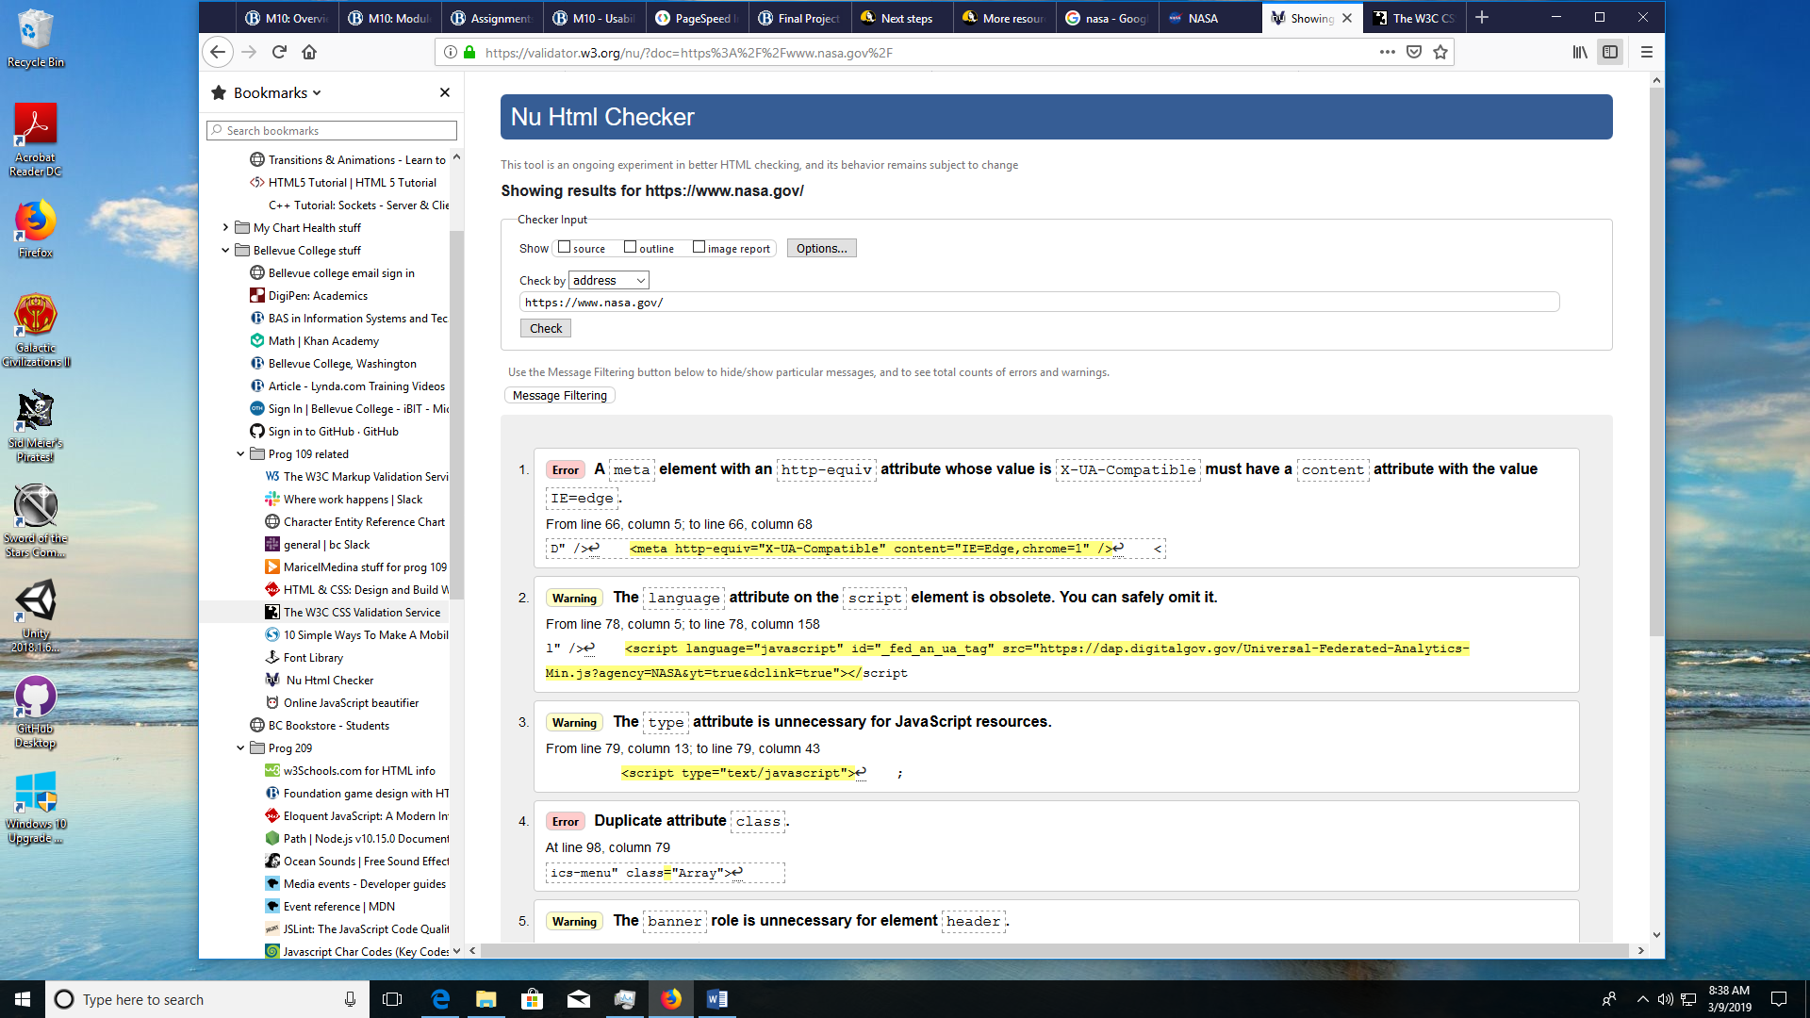

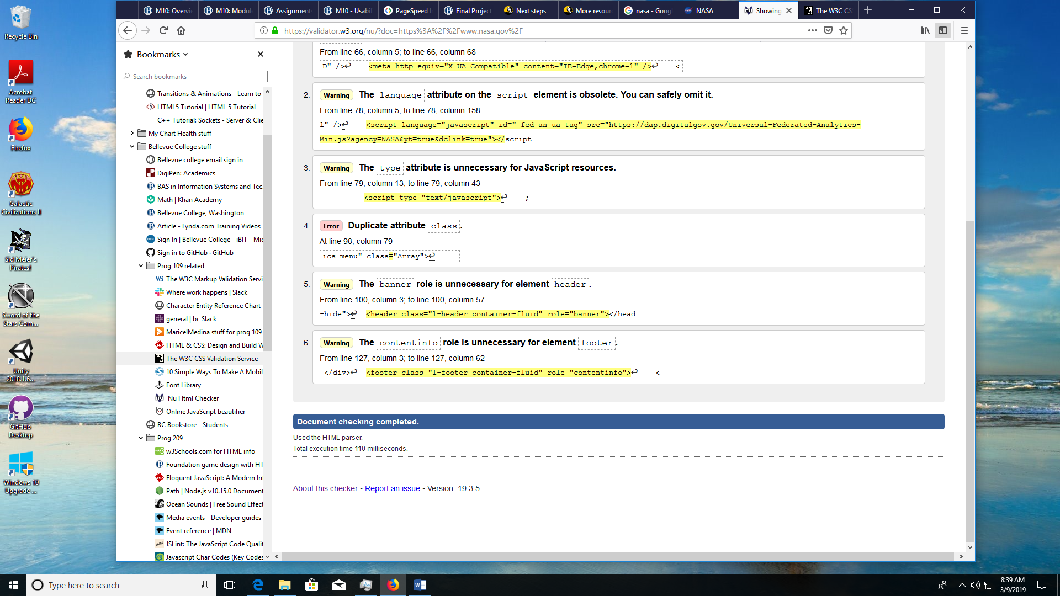

--------------------------------------------------------------------------------------------------------------------------

**CSS Validator:** **FAIL**

CSS Recommendations:

There are 44 errors and a ton of warnings for this page. 1 error is from the “vender” css, the rest from the nasa css.

1. 16 of the errors are incorrect selectors after “::-webkit-full-page-media” statements. The obvious recommendation is to correct these either by deletion or by putting in the correct selector.
2. Another 16 errors are the use of the “_:future” which is flagged as an unknown element or class. Upon inspection of the .css file, it is clear that _:future is being used as if it were some sort of an element, that is a valid attribute for the webkit-full-page-media statement from #1 above. However, “_:future” is never defined. The recommendation would be to delete all references to _:future.

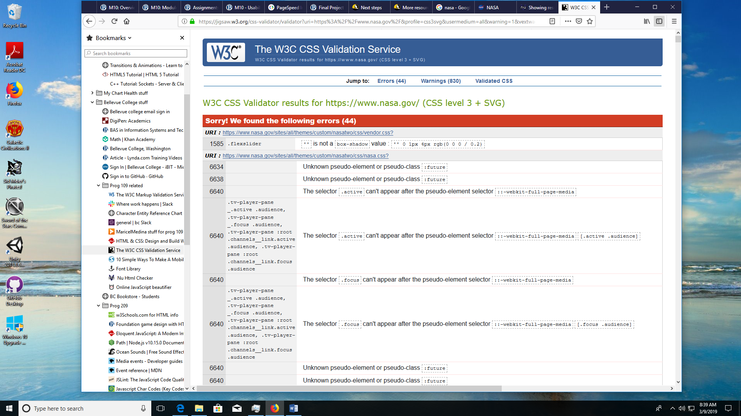

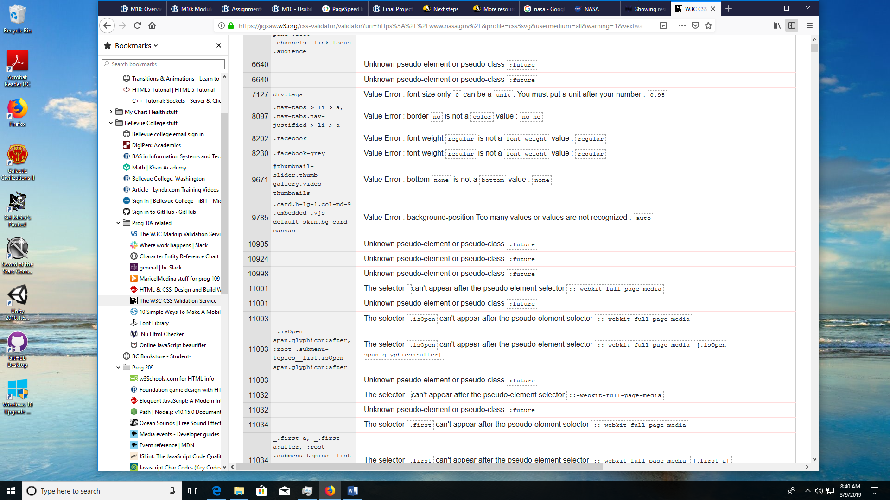

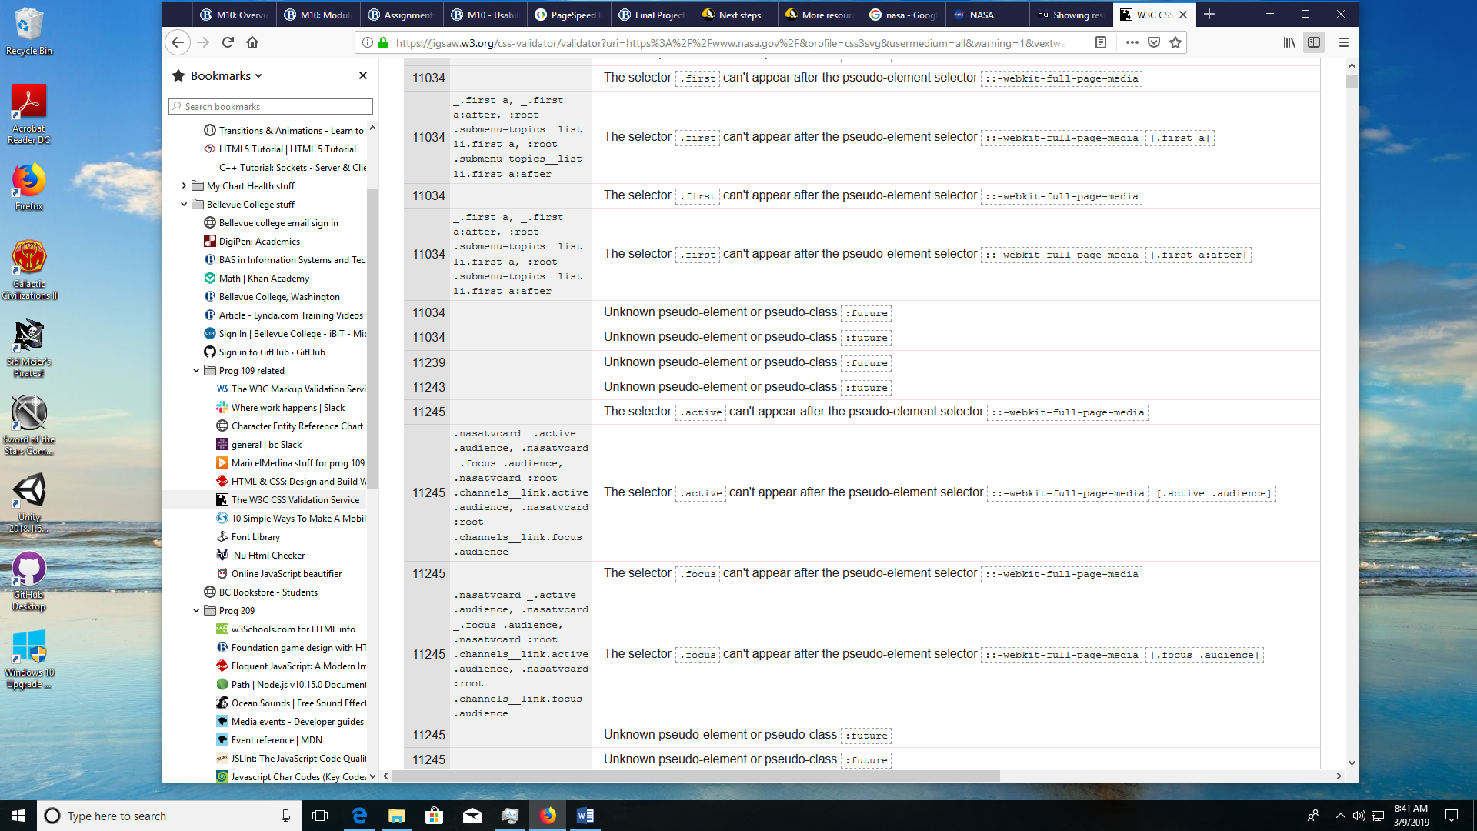

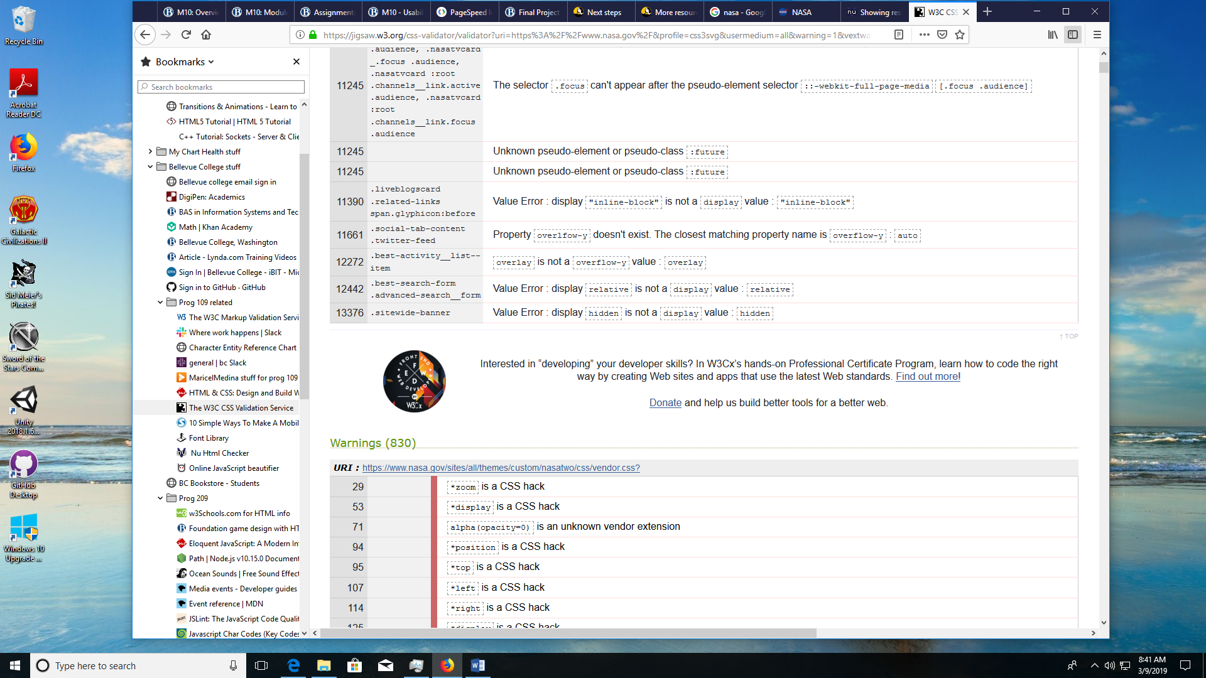

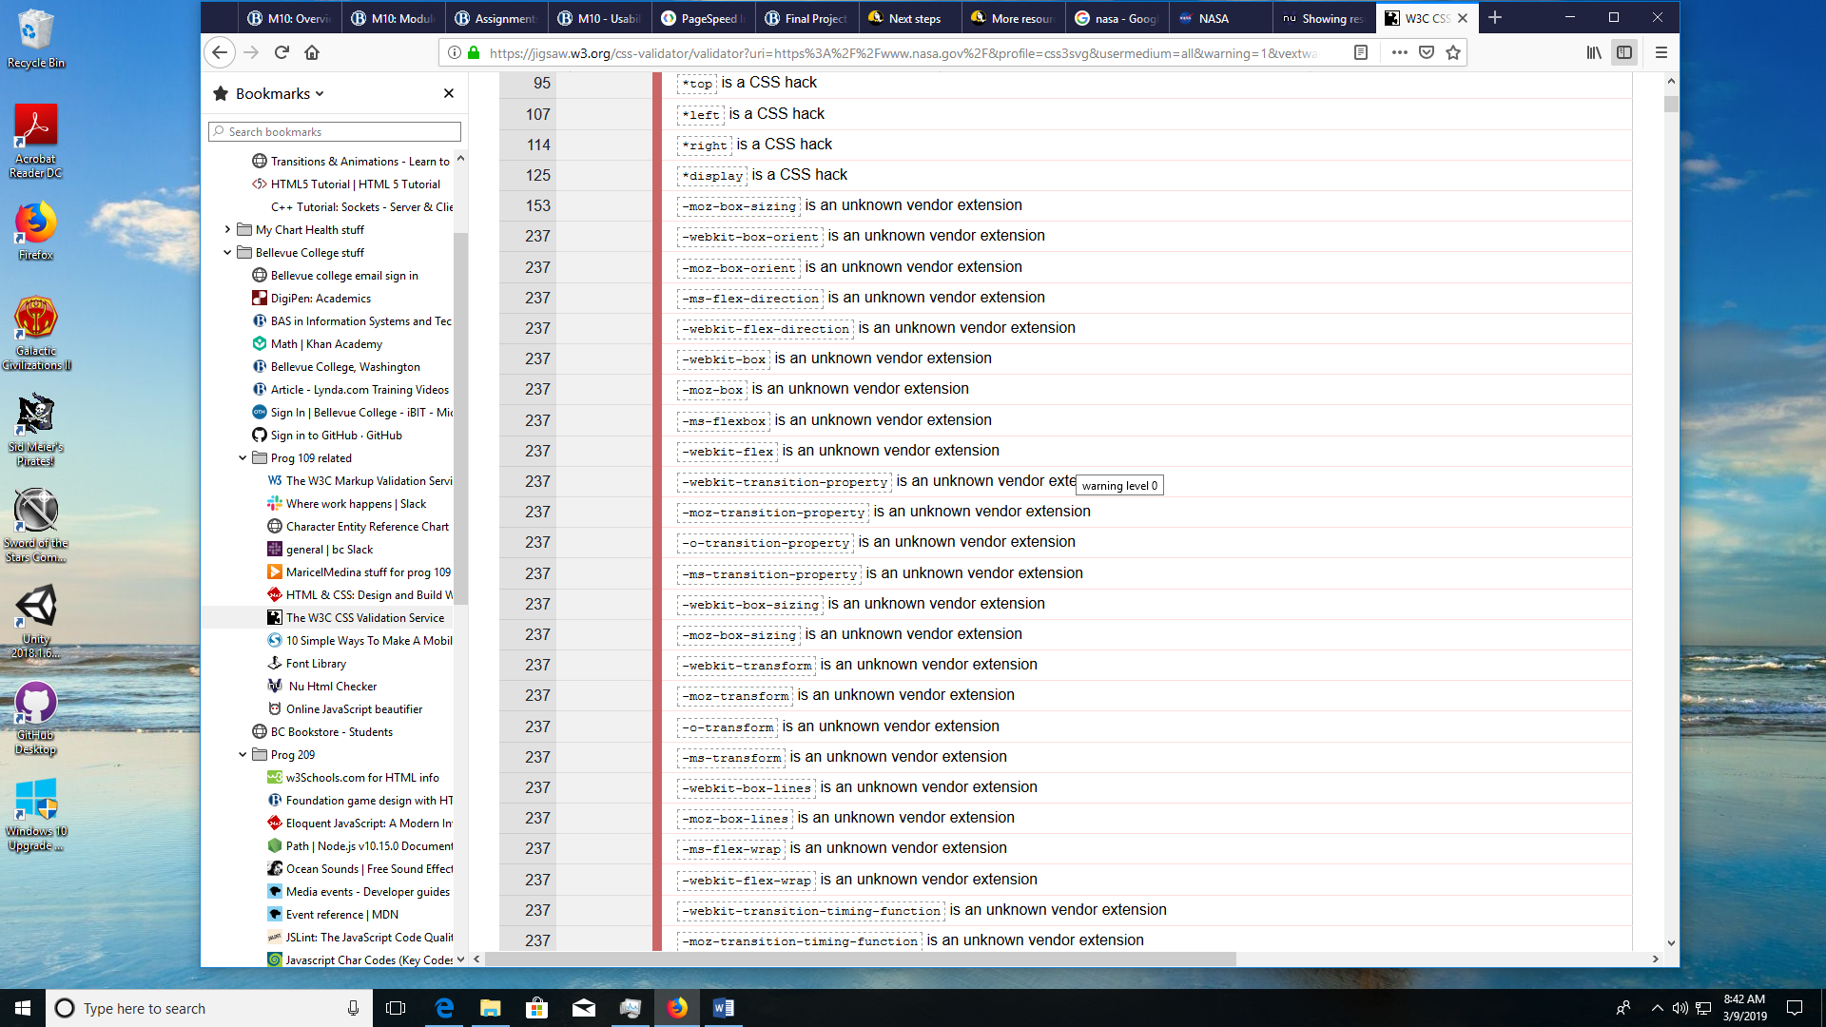

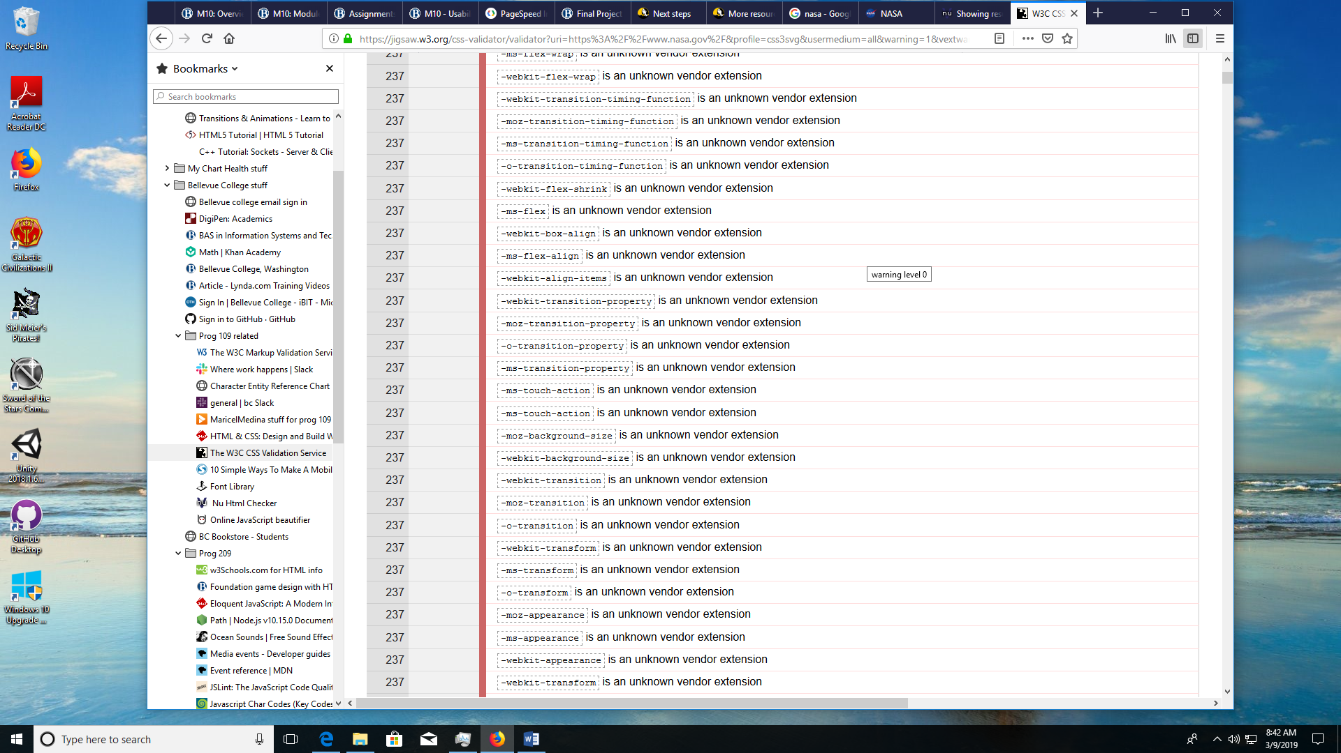

The CSS warnings continue for quite a few pages so stopping here.

----------------------------------------------------------------------------------------------------------------------------

**Page Speed:** **FAIL**

Page Speed Recommendations:

Well, there are obviously tons of possible opportunities here. However, from a user perspective, the worst offences are in the time it takes the page to load in the first place. Therefore, I would suggest the two opportunities presented by the page speed assessment:

1. Enable text compression for text-based resources to reduce network load. The biggest offenders being the two Java Script files and the two css files. This would practically cut the data load in half. (4mb to 2mb) with an estimated speed savings of a whopping 21.69 Seconds!
2. Eliminate render-blocking resources by just delivering the most critical css and js parts for the first page, first. We can have the rest of the css and js files load up after the first page has loaded. These are again the 4 files mentioned in item # 1. This would result in a potential speed savings of up to 18.69 Seconds!

